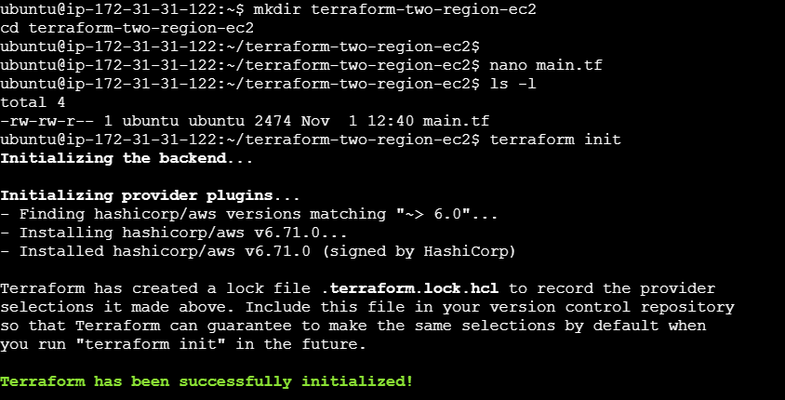

Terraform Validate
Resource added
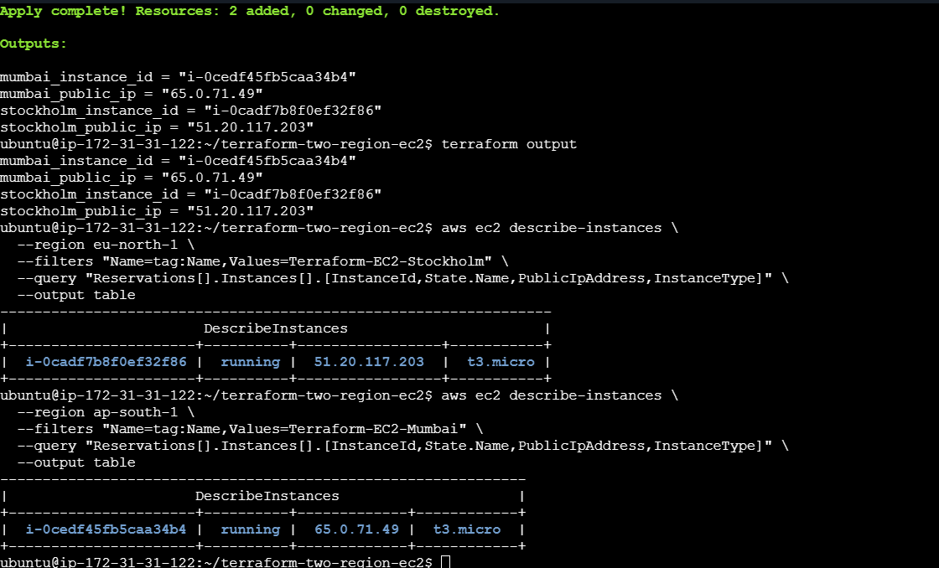

Mumbai Region
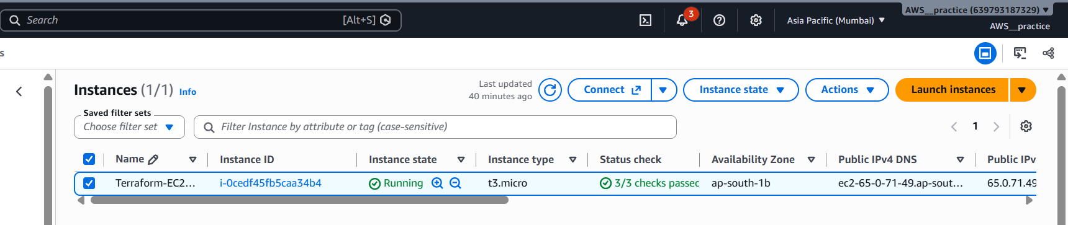
Stockholm Region


